Assignment 7

**Upload a static website in EC2 server.**

**Steps for creating an AWS account:**

1. **Sign in.** Sign in as a root user. Provide username and password when prompted.
2. Search on the search bar **EC2**. After that click on **Launch template** in the **EC2.**

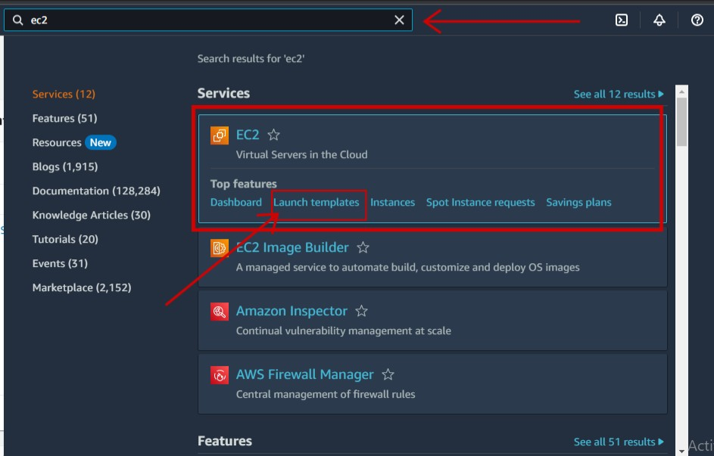

1. Now click on **Launch instances** and create a public bucket

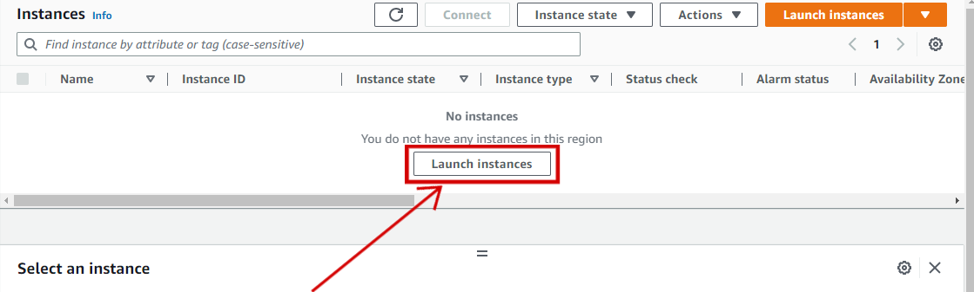

1. Enter the your server name.

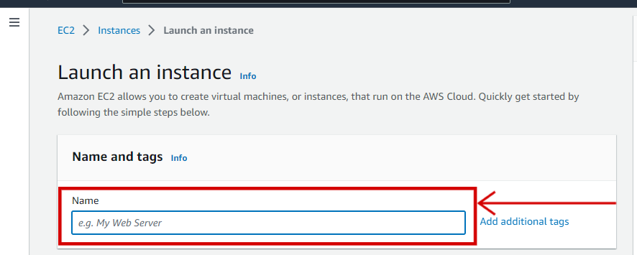

1. Click on **Ubuntu**.

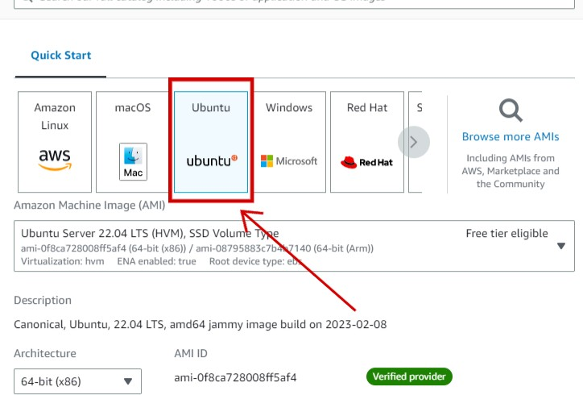

1. Click on **Create new key pair**.

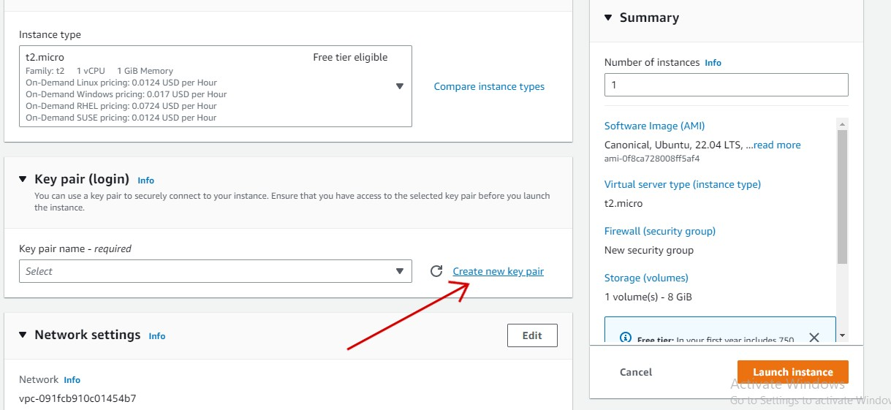

1. Enter the **Key Per Name**.

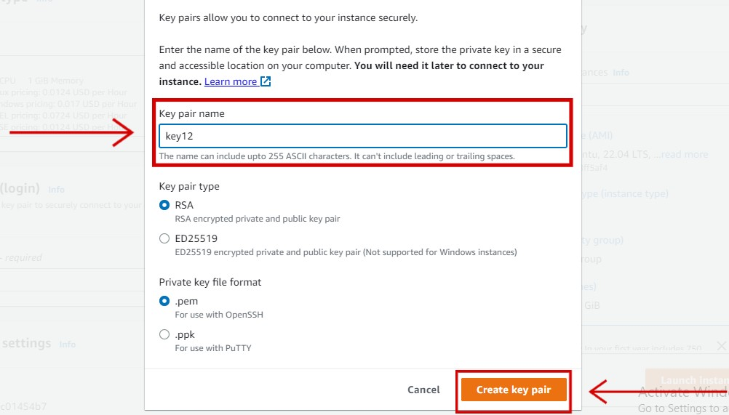

1. Click all the **check box**.

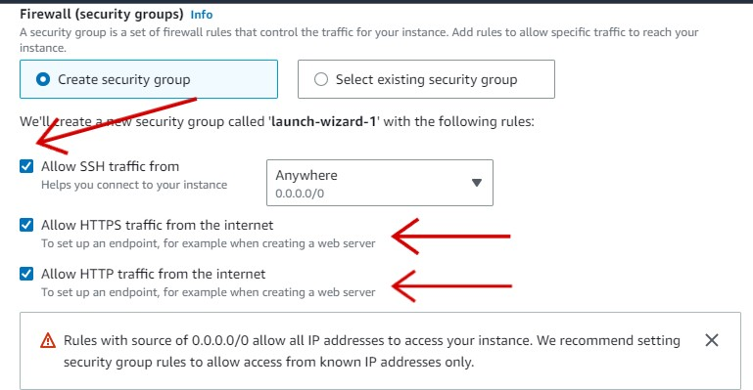

1. Click on **Launch Instances**.

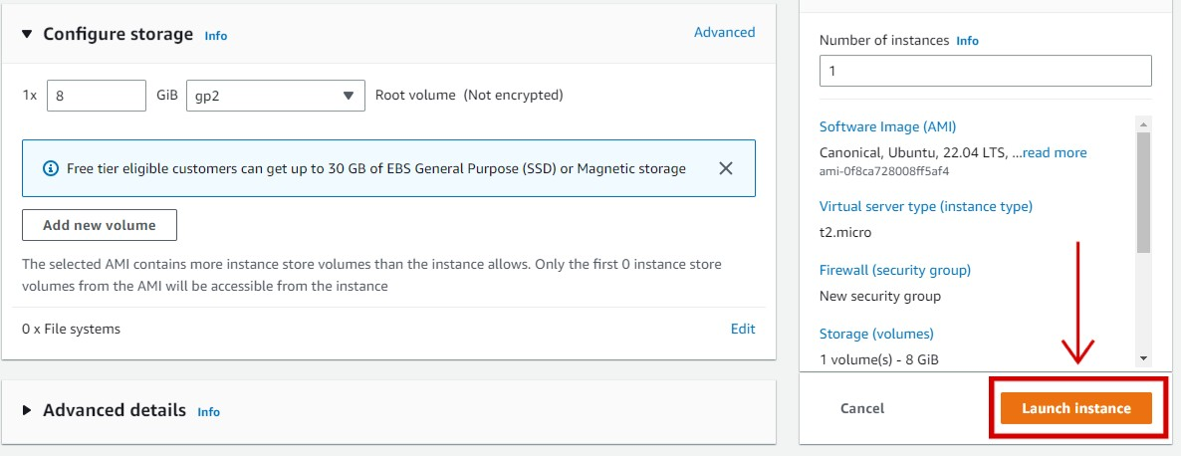

1. Click on **View all instances**.

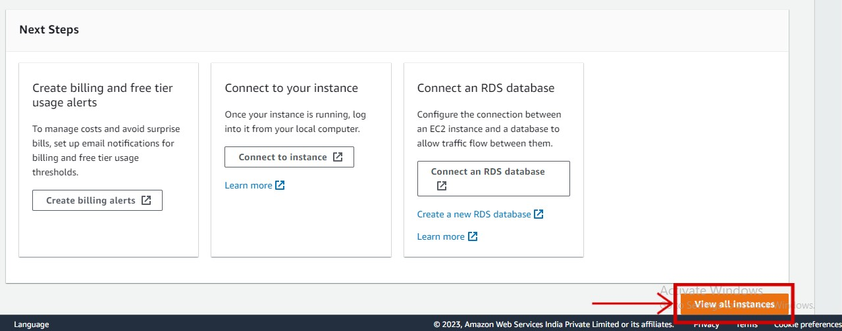

1. Now click on the **Instance ID number**.

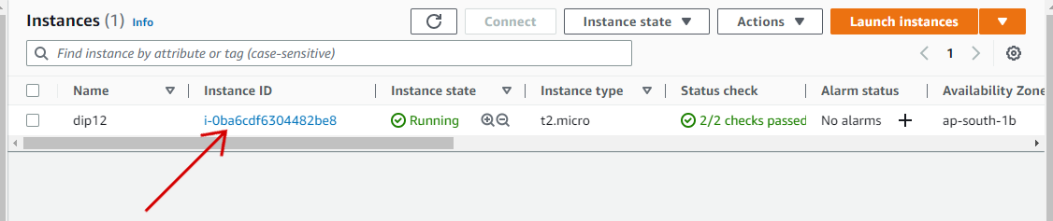

1. Now click on the **Public IPv4 address** to copy the IP.

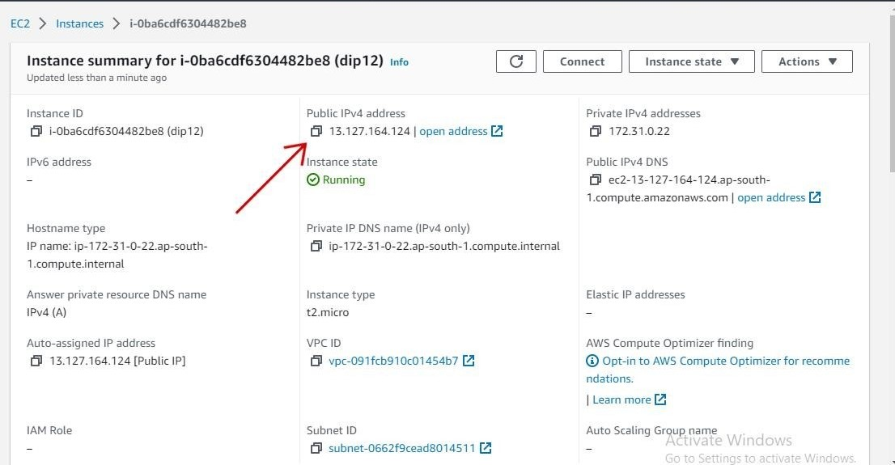

1. Now install the **Bitvise SSH client** on your pc.
2. **Paste** the **IP** in the **Host section** and enter a **user name**. After that click on **client key manager**.

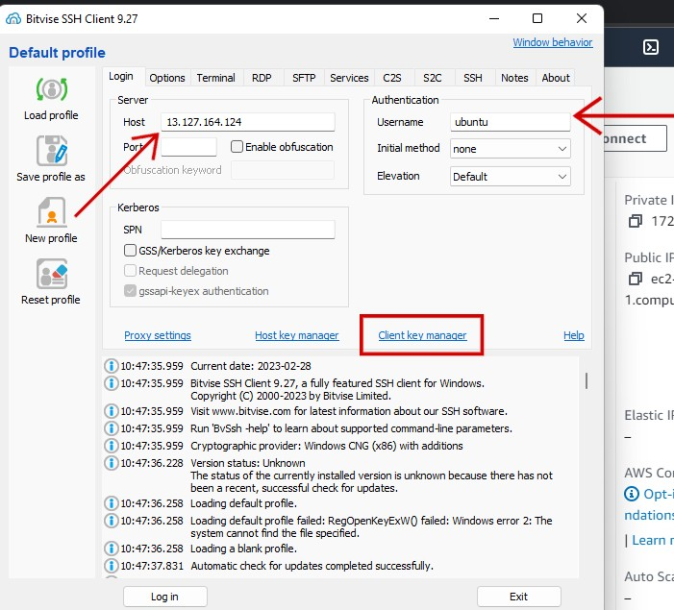

1. Now click on **import** to import the **key pair** that you have created the **step 7**.

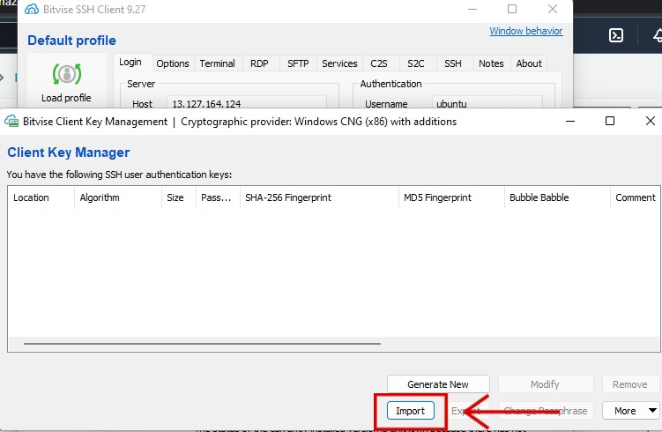

1. Set the **Initial method** as **publickey**.

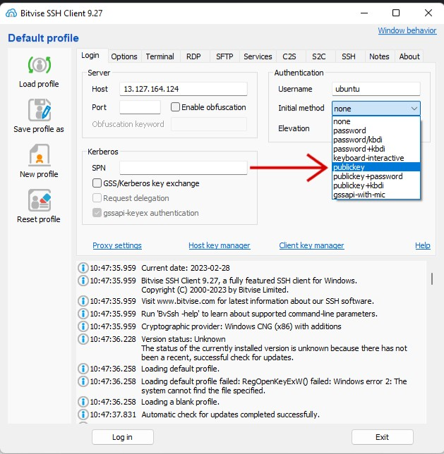

1. Set the **client key** as **Global 1**. After that click **Log in**.

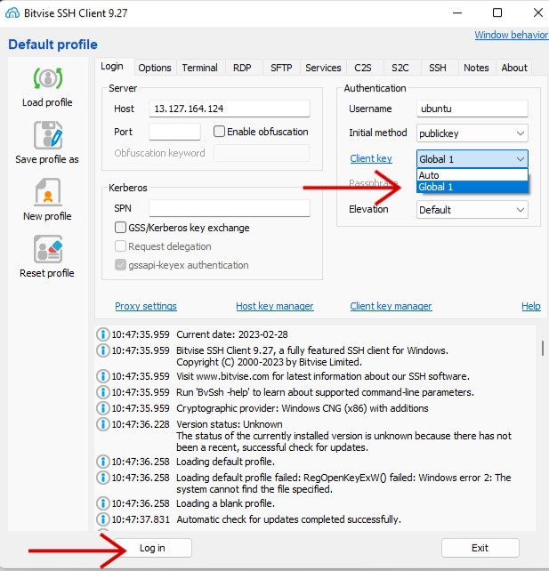

1. Click on **Accept and Save**.

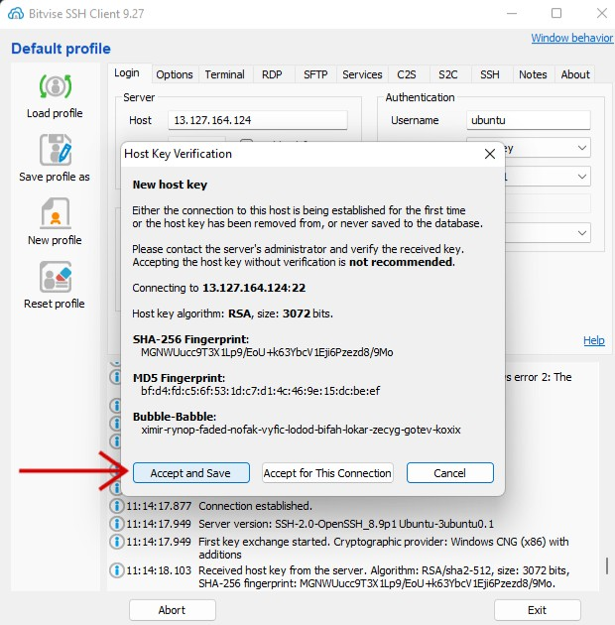

1. Click on **New terminal consol**.

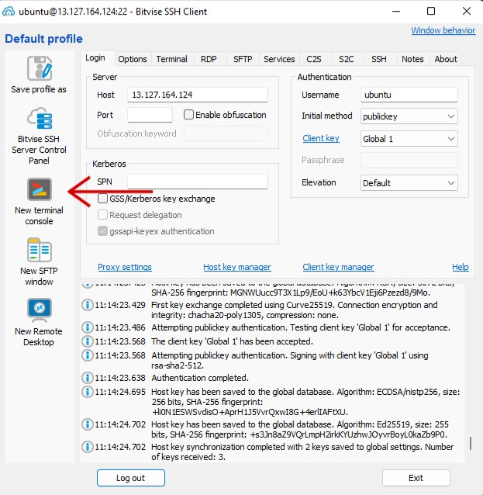

1. Enter these command on the consol.
   1. Enter **sudo apt update && sudo apt upgrade** to update the Ubuntu version.

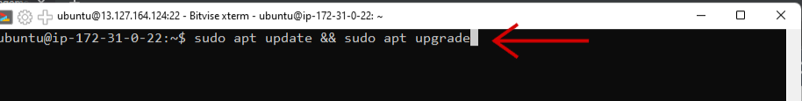

* 1. Enter **sudo apt install nginx** to install the nginx.

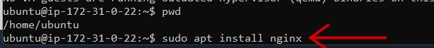

* 1. Enter the following command to change the directory from **/home /ubuntu** to

**/var/**[**www**.](http://www/)

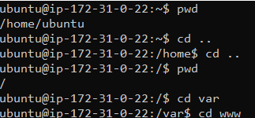

* 1. Enter **sudo chmod 777 html** to give all the permission.

C:\Users\ASUS\Desktop\aws\ass7(aws)\21.png

1. Click on **New SFTP window**.

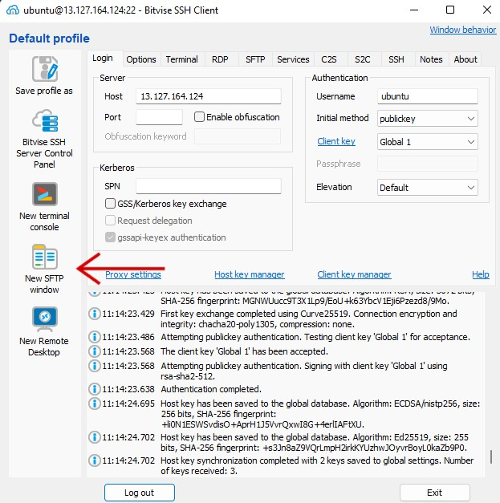

1. First enter **/** in the right bar to get in the root. After that click on **var**.

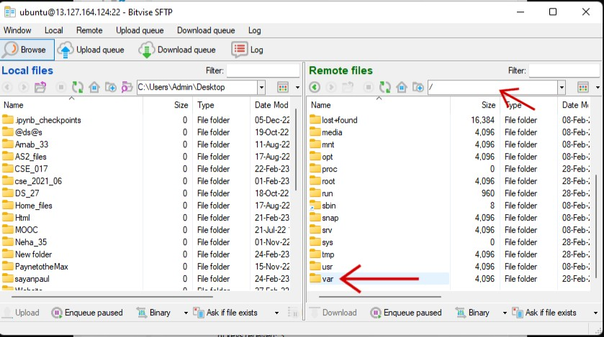

1. Now click on [**www**.](http://www/)

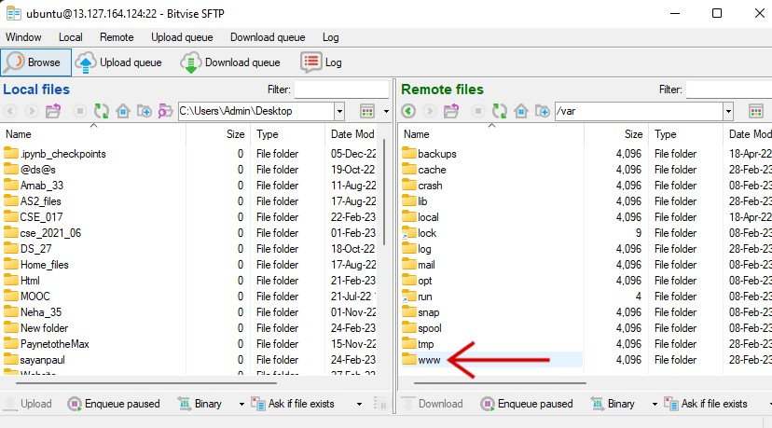

1. Now click on **html**. After that copy the **static website file form local file** (which in on the local pc) and **paste it in the html file in the remote file section**.

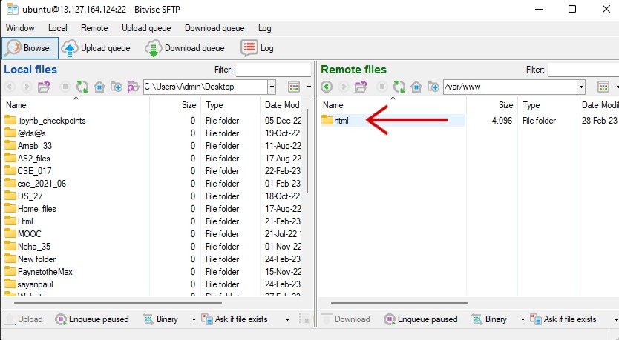

1. Now come back to AWS and copy the same IP.

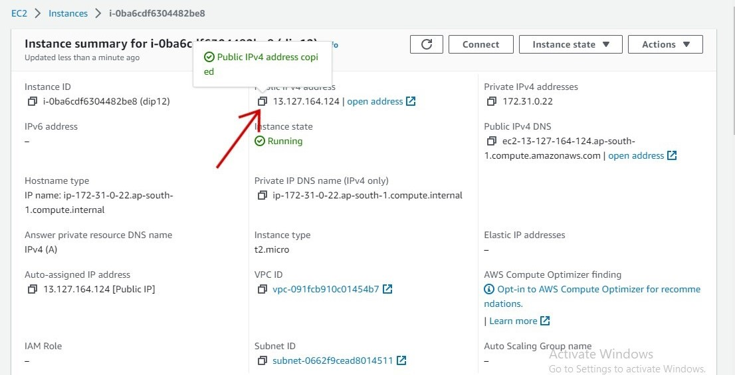

1. Now paste the IP in a new tab. Now your static website is live on the EC2 server.

